Default Report  
*Site user experience survey for http://machinelearningalgorithmsillustrated.azurewebsites.net/*  
**December 4th 2016, 1:03 am MST**

**Q1 - Thanks for taking the time to answer this survey. It will take you about 15 minutes for this survey.
Section 1, prerequisites(Answer before visiting site) What’s your math level in terms of machine learning?Site url: http://machinelearningalgorithmsillustrated.azurewebsites.net/**

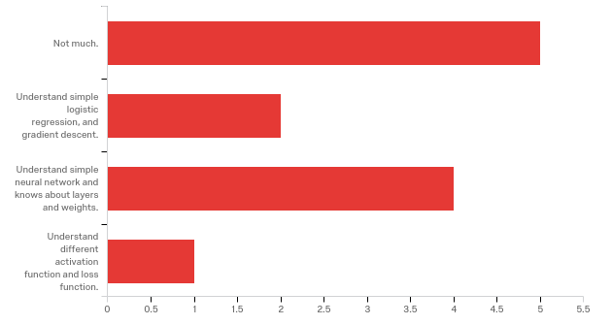

|  |  |  |  |
| --- | --- | --- | --- |
| # | Answer | % | Count |
| 1 | Not much. | 41.67% | 5 |
| 2 | Understand simple logistic regression, and gradient descent. | 16.67% | 2 |
| 3 | Understand simple neural network and knows about layers and weights. | 33.33% | 4 |
| 4 | Understand different activation function and loss function. | 8.33% | 1 |
|  | Total | 100% | 12 |

**Q2 - Section 2, home page(Answer after viewing home page) Describe the goal of the project:**

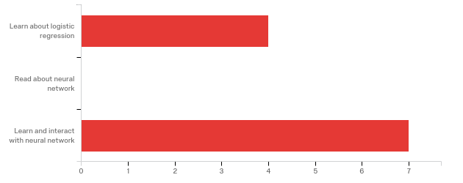

|  |  |  |  |
| --- | --- | --- | --- |
| # | Answer | % | Count |
| 1 | Learn about logistic regression | 36.36% | 4 |
| 2 | Read about neural network | 0.00% | 0 |
| 3 | Learn and interact with neural network | 63.64% | 7 |
|  | Total | 100% | 11 |

**Q4 - Section 3, learn page(Answer after viewing learn page) What are the inputs and output of the toy example?**

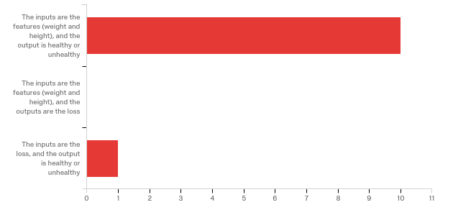

|  |  |  |  |
| --- | --- | --- | --- |
| # | Answer | % | Count |
| 1 | The inputs are the features (weight and height), and the output is healthy or unhealthy | 90.91% | 10 |
| 2 | The inputs are the features (weight and height), and the outputs are the loss | 0.00% | 0 |
| 3 | The inputs are the loss, and the output is healthy or unhealthy | 9.09% | 1 |
|  | Total | 100% | 11 |

**Q5 - What are model parameters?**

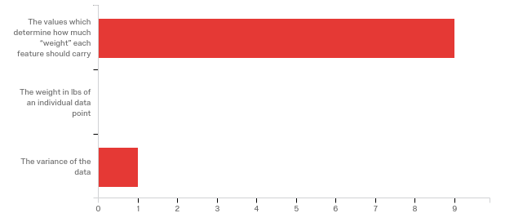

|  |  |  |  |
| --- | --- | --- | --- |
| # | Answer | % | Count |
| 1 | The values which determine how much “weight” each feature should carry | 90.00% | 9 |
| 2 | The weight in lbs of an individual data point | 0.00% | 0 |
| 3 | The variance of the data | 10.00% | 1 |
|  | Total | 100% | 10 |

**Q6 - What question will a trained model be able to answer in the toy example?**

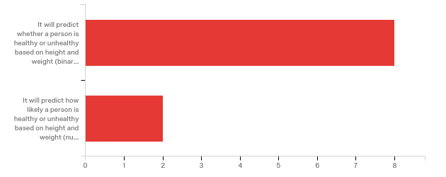

|  |  |  |  |
| --- | --- | --- | --- |
| # | Answer | % | Count |
| 1 | It will predict whether a person is healthy or unhealthy based on height and weight (binary output) | 80.00% | 8 |
| 2 | It will predict how likely a person is healthy or unhealthy based on height and weight (numeric output) | 20.00% | 2 |
|  | Total | 100% | 10 |

**Q7 - How many phases are in the learning of a neural network?**

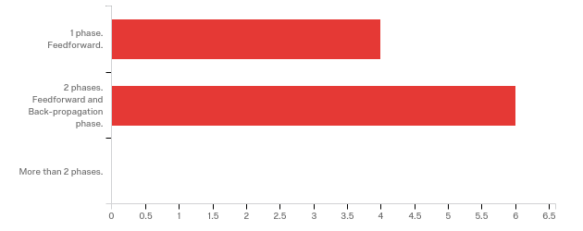

|  |  |  |  |
| --- | --- | --- | --- |
| # | Answer | % | Count |
| 4 | 1 phase. Feedforward. | 40.00% | 4 |
| 5 | 2 phases. Feedforward and Back-propagation phase. | 60.00% | 6 |
| 6 | More than 2 phases. | 0.00% | 0 |
|  | Total | 100% | 10 |

**Q8 - Why is simple logistic regression no longer suitable when “tall skinny guys” show up?**

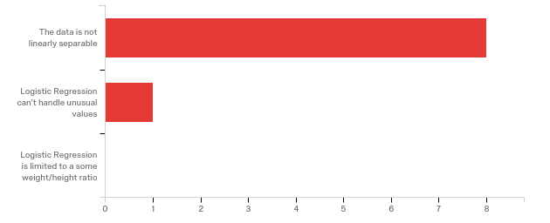

|  |  |  |  |
| --- | --- | --- | --- |
| # | Answer | % | Count |
| 1 | The data is not linearly separable | 88.89% | 8 |
| 2 | Logistic Regression can’t handle unusual values | 11.11% | 1 |
| 3 | Logistic Regression is limited to a some weight/height ratio | 0.00% | 0 |
|  | Total | 100% | 9 |

**Q9 - What does the loss chart show?**

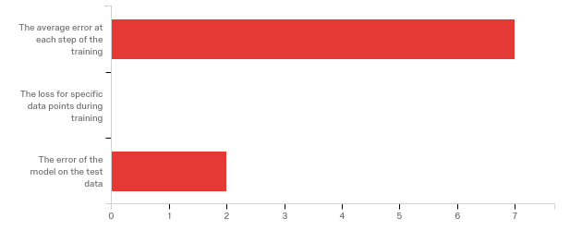

|  |  |  |  |
| --- | --- | --- | --- |
| # | Answer | % | Count |
| 1 | The average error at each step of the training | 77.78% | 7 |
| 2 | The loss for specific data points during training | 0.00% | 0 |
| 3 | The error of the model on the test data | 22.22% | 2 |
|  | Total | 100% | 9 |

**Q10 - What does the gradient descent chart show?**

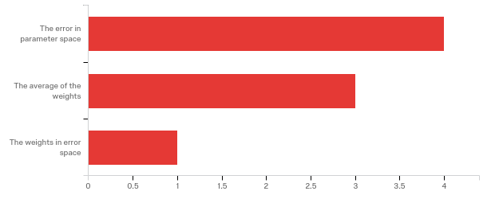

|  |  |  |  |
| --- | --- | --- | --- |
| # | Answer | % | Count |
| 1 | The error in parameter space | 50.00% | 4 |
| 4 | The average of the weights | 37.50% | 3 |
| 3 | The weights in error space | 12.50% | 1 |
|  | Total | 100% | 8 |

**Q11 - Why is the hyperplane different between logistic regression and single layer neural network?**

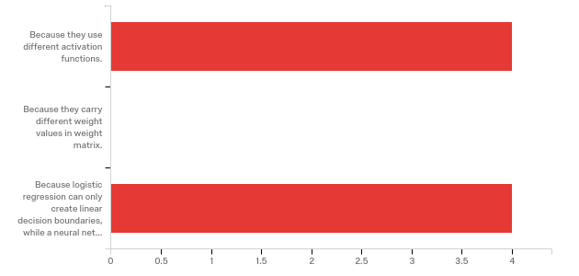

|  |  |  |  |
| --- | --- | --- | --- |
| # | Answer | % | Count |
| 1 | Because they use different activation functions. | 50.00% | 4 |
| 2 | Because they carry different weight values in weight matrix. | 0.00% | 0 |
| 3 | Because logistic regression can only create linear decision boundaries, while a neural network with hidden layers is capable of creating non-linear decision boundaries | 50.00% | 4 |
|  | Total | 100% | 8 |

**Q13 - Section 4, play page(Answer after viewing play page, and build a model with two layers with 10 nodes each) What is the training loss?**

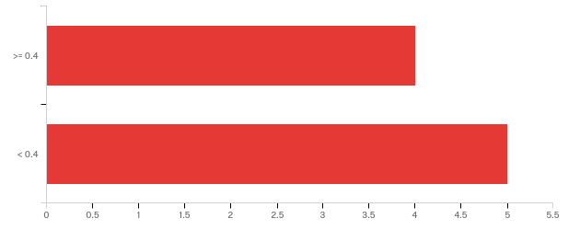

|  |  |  |  |
| --- | --- | --- | --- |
| # | Answer | % | Count |
| 1 | >= 0.4 | 44.44% | 4 |
| 2 | < 0.4 | 55.56% | 5 |
|  | Total | 100% | 9 |

**Q14 - What is the test loss?**

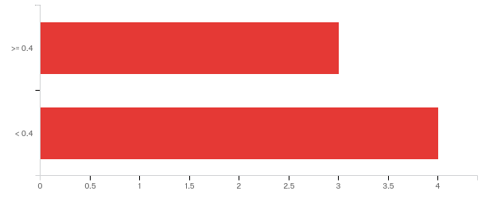

|  |  |  |  |
| --- | --- | --- | --- |
| # | Answer | % | Count |
| 1 | >= 0.4 | 42.86% | 3 |
| 2 | < 0.4 | 57.14% | 4 |
|  | Total | 100% | 7 |

**Q15 - What information to the tooltips on the matrices provide?**

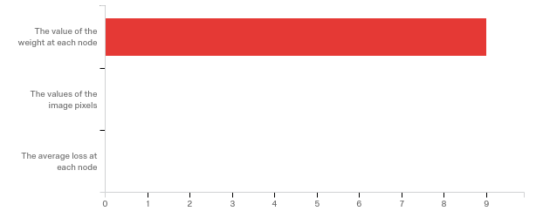

|  |  |  |  |
| --- | --- | --- | --- |
| # | Answer | % | Count |
| 1 | The value of the weight at each node | 100.00% | 9 |
| 2 | The values of the image pixels | 0.00% | 0 |
| 3 | The average loss at each node | 0.00% | 0 |
|  | Total | 100% | 9 |

**Q16 - Where on the page are the model parameters?**

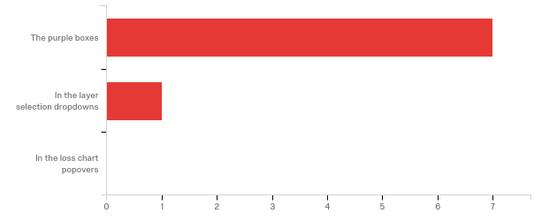

|  |  |  |  |
| --- | --- | --- | --- |
| # | Answer | % | Count |
| 1 | The purple boxes | 87.50% | 7 |
| 2 | In the layer selection dropdowns | 12.50% | 1 |
| 4 | In the loss chart popovers | 0.00% | 0 |
|  | Total | 100% | 8 |

**Q17 - Section 5, LR;DR page (too long didn't read lol)(Answer after viewing LR;DR page) Is this section helpful?**

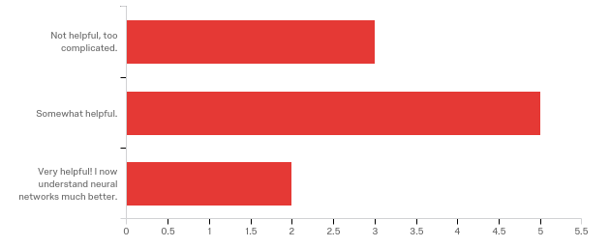

|  |  |  |  |
| --- | --- | --- | --- |
| # | Answer | % | Count |
| 1 | Not helpful, too complicated. | 30.00% | 3 |
| 2 | Somewhat helpful. | 50.00% | 5 |
| 3 | Very helpful! I now understand neural networks much better. | 20.00% | 2 |
|  | Total | 100% | 10 |

**Q18 - Section 6, overall site experience(Last section) Did you learn anything new by using this project?**

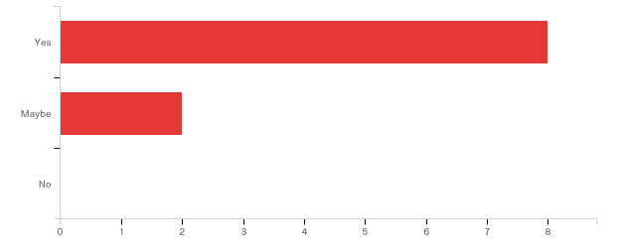

|  |  |  |  |
| --- | --- | --- | --- |
| # | Answer | % | Count |
| 1 | Yes | 80.00% | 8 |
| 2 | Maybe | 20.00% | 2 |
| 3 | No | 0.00% | 0 |
|  | Total | 100% | 10 |

**Q19 - Did this project help you get some insight into the mechanics of NNs?**

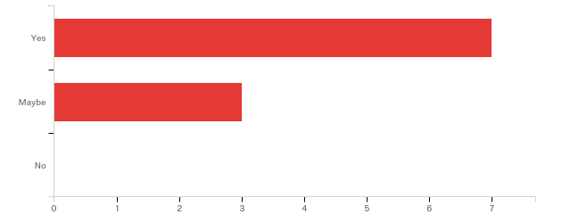

|  |  |  |  |
| --- | --- | --- | --- |
| # | Answer | % | Count |
| 1 | Yes | 70.00% | 7 |
| 2 | Maybe | 30.00% | 3 |
| 3 | No | 0.00% | 0 |
|  | Total | 100% | 10 |

**Q20 - Was there anything particularly frustrating or unclear?**

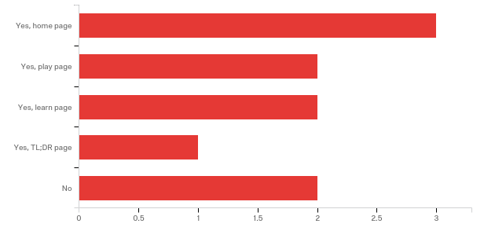

|  |  |  |  |
| --- | --- | --- | --- |
| # | Answer | % | Count |
| 1 | Yes, home page | 30.00% | 3 |
| 2 | Yes, play page | 20.00% | 2 |
| 4 | Yes, learn page | 20.00% | 2 |
| 5 | Yes, TL;DR page | 10.00% | 1 |
| 3 | No | 20.00% | 2 |
|  | Total | 100% | 10 |

**Q21 - What did you like best?**

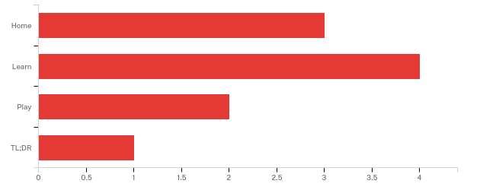

|  |  |  |  |
| --- | --- | --- | --- |
| # | Answer | % | Count |
| 1 | Home | 30.00% | 3 |
| 2 | Learn | 40.00% | 4 |
| 3 | Play | 20.00% | 2 |
| 4 | TL;DR | 10.00% | 1 |
|  | Total | 100% | 10 |